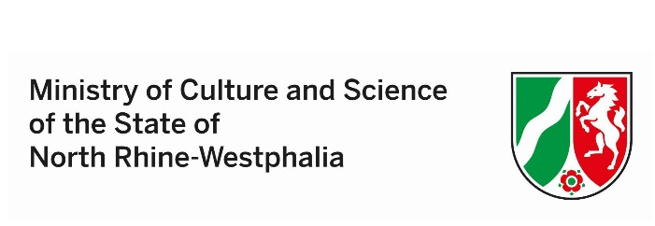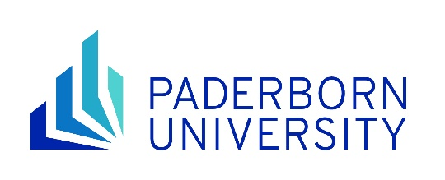

Self-declaration of income for the application for the NRWege ins Studium scholarship at Paderborn University

Last name: | Click or type here to enter text.
First name: | Click or type here to enter text.
Place of birth: | Click or type here to enter text.
Date of birth: | Click or type here to enter text.
Address: | Click or type here to enter text.
E-mail address: | Click or type here to enter text.

Please provide full details of your average monthly income over the last 4 months, excluding special payments such as overtime or Christmas bonus.

Type of income | Amount in euros
Regular income from work, part-time job, internship (average net earnings per month)  When does the work contract end: DD/MM/YYYY: Click or type here to enter text. | Type here to enter text
State support (BAföG, Jobcenter, Sozialamt, etc.)  When does this support end: DD/MM/YYYY: Click or type here to enter text. | Type here to enter text
Regular support from parents, family, spouse or friends (total)  (This is about support for the scholarship holder and not for family members, i.e. children, spouse) | Type here to enter text
Scholarships  Name of the scholarship: Click or type here to enter text. | Type here to enter text
Other regular or one-time income (total amount)  Please name: Click or type here to enter text. | Type here to enter text

I confirm the accuracy and completeness of the information I have provided and undertake to inform the International Office immediately of any changes to my personal details and financial situation during the application period or, if funding is awarded, by the end of the funding period.

I agree to make the supporting documents available for verification of the above information at any time.

I am aware that false or incomplete information may lead to the reclaiming of the approved funding and may have consequences under criminal law.

Type here to enter text
Place, date Signature
Page 1 of 1

