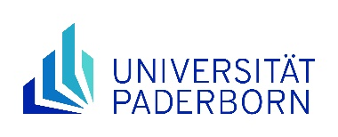 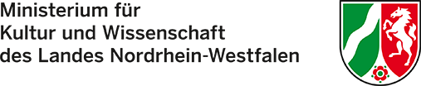

**Application and motivation letter for funding under the "NRWege ins Studium" programme**

I hereby request ______________________  
 Last Name, First Name

______________________

Matriculation number

a place on the NRWege DSH language course in the

O 1st quarter `25 O 2nd quarter `25 O 3rd quarter `25 O 4th quarter `25

I am currently participating in a "NRWege ins Studium" support programme.: O yes

O no

If you are currently enrolled in a DSH language course at Paderborn University, please indicate your current course (e.g. Mittelstufe II A or Oberstufe B):

I have read the [Declaration of consent](https://www.uni-paderborn.de/en/studies/international-students/refugees-welcome/nrwege-ins-studium) and I agree that

* my data will be stored for the processing of the application and my participation data (for statistical evaluation purposes and possible queries) will be passed on to the Ministry of Culture and Science in North Rhine-Westphalia (MKW NRW)
* I will participate in at least one further NRWege programme at Paderborn University during the funding period

I further confirm that I have not resided in Germany for more than 5 years and that I obtained my higher education entrance qualification abroad.

The reasons for my application can be found on page 2 of the application in the motivation letter.

**IMPORTANT**: When applying for NRWege funding, **payment of course fees only after refusal**!

Paderborn, ________________ _____________________________________  
 (Date) (Signature)

*Please send us the* ***signed******application****, including the* ***letter of motivation*** *on* ***page 2*** *and a scan of your* ***current residence document*** *as a* ***PDF document*** *to:* [*io-refugees@zv.upb.de*](mailto:io-refugees@zv.upb.de)

**Letter of Motivation for the Application for Funding under the "NRWege ins Studium" Programme:**

Please explain in a short statement your personal situation and why you should be supported by the NRWege programme. Please do not exceed the scope of this page!

Paderborn, ________________ _____________________________________  
 (Date) (Signature)